**PLEASE READ THE INFORMATION BELOW!!**

**YOUR SUPPORT IS OUR LIFE BLOOD!!**

**Dear Member and Supporter**

**Your Public Radio Station KTXK is at a crossroads. KTXK has been in a struggle for the last two years because of the effects of Covid on the bottom line. Our income from businesses and individuals like you to support the programming you hear every day has suffered.**

**I MUST BE HONEST WITH YOU ON WHAT WE ARE FACING:**

1. **We are NOW in danger of losing our financial support from the Corporation for Public Broadcasting, because of the decrease of funding both local and Institutional. We must make up $70,000 dollars in each of the next three years to remain qualified for CPB Funding. This is the money lost during the Pandemic.**
2. **If lost, KTXK will be very hard pressed to continue as an NPR affiliate with its program offerings.**
3. **We must prove to the CPB for the next three years that this community supports Public Broadcasting.**

**HOW CAN YOU HELP**

1. **Think about what KTXK means to you**
2. **If you are able, contribute what you can to support this Public Radio service during this pledge drive, but only if you can. We never want listeners to Public Radio to give if they are unable too.**
3. **Let us know how important we are to you by e mailing steve@ktxk.org**

**I also encourage our members to call me anytime with a concern you may have at 903 748 4541 or e mail me to** [**steve@ktxk.org**](mailto:steve@ktxk.org)**.**

**Steve Mitchell**

**KTXK GM**

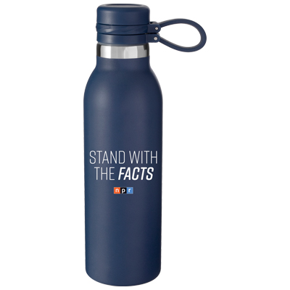

**20 OZ DOUBLE WALL STAINLESS STEEL THERMAL BOTTLE WITH VACUUM INSULATION**



**PEN**

**20 OZ DOUBLE WALL STAINLESS STEEL THERMAL TUMBLER WITH VACUUM INSULATION**

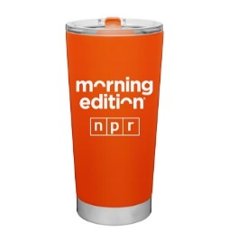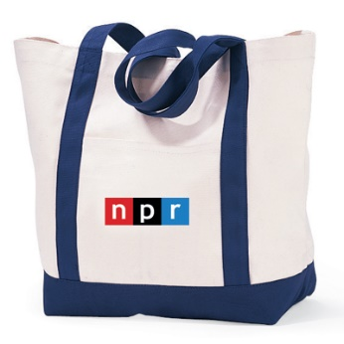**TOTE BAG**

**KTXK SPRING 2022 MEMBERSHIP PLEDGE DRIVE:**

**MAKE YOURSELF HEARD “PUBLIC RADIO IS MY CHOICE’**

**REMEMBER YOU CAN USE YOUR**

**MASTER CARD or VISA to make your pledge.**

**Remember that for your convenience you can also make your pledge on line at**

**ktxk.org. OR Call anytime 903 748 4541**

## How much would you like to pledge in support of KTXK Programming? __________

NAME: ______________________________________________________________

#, street, or PO Box

ADDRESS: ____________________________________________________________________________________________________

CITY/ZIP:_____________________________________________________________________________________________________

PHONES - HOME: **870 /903**__________________________WORK: **870 /903**__________________________

**🞎 GIFTS OF $1 TO $50 “I WANT MY NPR”**

**🞎 GIFTS OF $75 TO $125 OR MORE 🞎 KTXK PEN**

**🞎 GIFTS OF $150 OR MORE 🞎 NPR 20 OZ STEEL THERMAL TRAVEL MUG or TUMBLER**

**🞎 GIFTS OF $175.🞎 NPR HEAVY CANVAS TOTE BAG**

**🞎 $200 This is a great way to promote your business or nonprofit RIGHT NOW!!!!!**

**If you pledge at this level or above you can receive a full month of announcements on the air for your business, church or any nonprofit you wish to promote. You will receive 40 announcements that will air in NPR Programming Monday Thru Friday. You support two nonprofits with one pledge. KTXK and your other favorite nonprofit. Simply choose this option and we will be in touch with you. Please identify the business or agency you wish to promote. This is one of our most popular choices. PLUS PEN**

**🞎 $250 OR ABOVE “The Big Thank You” 30 announcements for your favorite Nonprofit, PLUS YOU RECEIVE**

**TOTE BAG, PEN, AND TRAVEL MUG**

**🞎 DO NOT SEND PREMIUM I WANT ALL OF MY PLEDGE TO SUPPORT KTXK’S “THINK” PROGRAMMING “KEEP NPR AND KTXK IN MY HOME, AND IN MY CAR”**

**🞎 CHECK ENCLOSED** **🞏 VISA or**  **🞏 MasterCard**  (No other cards accepted!)

Card #_______________________________________________________ Exp. Date: ___________________